Week Commencing 30.3.20

Home Topic Grid

Research some interesting facts about Queen Victoria  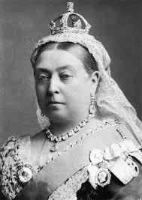 | Go on a nature hunt in the garden and make a pictogram showing all of the things you found.  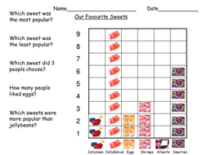 | Complete the daily Lego challenge. Post some pictures to show me of what you have made.  https://www.themummytoolbox.com/lego-building-kids-activity-for-30-days-free-printable/?fbclid=IwAR2ORVbq57MKHzufaiJrddHGkkD7WkrNIvc_okLx1xlJJY3i3L38n1NSLCQ
Read your favourite book. Choose a character from it and write a character description about them. Remember to include what they look like, what they like and how they behave. | Draw some beautiful flowers that you have found outside. | Roll your dice twice and make a 2 digit number. Then roll the dice once to create a number sentence. Then add the two numbers and then take them away use your numberline to help.  23 + 4 = 27  23 – 4 = 19

