**PE**

Rounders

Athletics

Swimming

**Husky Class**

**Summer Term 2022**

**Sidlesham to the South Downs – What exactly IS West Sussex?**

**Science**

Life cycles linked to the South Downs

Humans and animals –

Circulatory system, Digestive system

The impact of diet, drugs and exercise on humans

How humans change from birth to old age.

**DT and Art**

Landscapes and perspectives

Digital photography

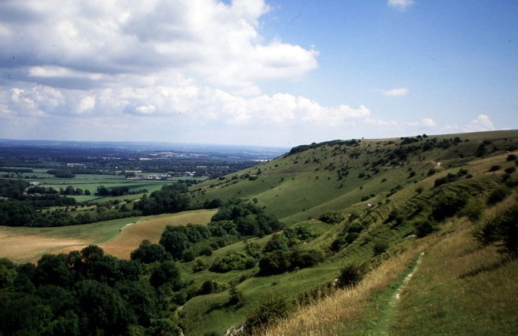

**History**

How land uses have changed in the South Downs over time.

Land Settlement Associations

**Class Texts**

**The Wee Free Men –** Terry Prachett

**Kay’s Anatomy -** Adam Kay

**My Amazing Body Machine -** Robert Winston

**The World around me –** Charlotte Guillain

**Maps of the United Kingdom –** Rachel Dixon

**Literacy / English**

Characters

Myths and legends – writing our own local legends

Discussion texts – The South Downs should be developed for housing.

Double page spreads linked to our Geography and Science work

**Computing**

E safety

Recording and presenting data using Excel and Google Sheets

Using formulas

**Music**

Music and Me

Reflect, Rewind, Replay

**Relationships**

Transitioning

Friendships

Making good choices

**Mathematics**

Algebra

Statistics – different graphs, recording data and analysing it.

Ratio

Dragon’s Den – Business plan

**Geography**

Exploring maps at different scales of the local area and the South Downs

Looking at land use over time

Understanding grid references and compasses

Creating sketch maps of areas

Topography, human and physical features.

Cities and settlements